# **PROOF OF POSTING NOTICE OF SPECIAL MEETING**

## I am a citizen of the United States and a resident of Yolo County, California. I am over the age of eighteen years.

On ___6/16/205________________, I posted within the boundaries of the District of RECLAMATION DISTRICT NO. 1600 the NOTICE OF SPECIAL MEETING OF RECLAMATION DISTRICT NO. 1600 to be held on June 19, 2025 at 3:00 PM at Bypass Farms, 14130 County Road 117, West Sacramento, California.

## I declare under penalty of perjury under the laws of the State of California that the forgoing is true and correct.

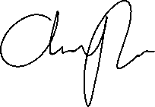

_______________________________

**AMMY REYES, Secretary**

**Reclamation District 1600**